Term 1 Week 9 Lesson 2_ Reading Scatterplots worksheet.

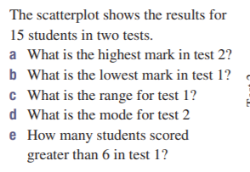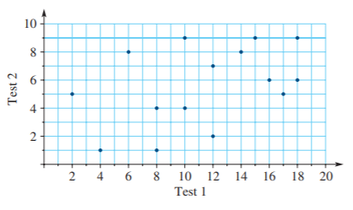

Delete this instruction and begin your answer here
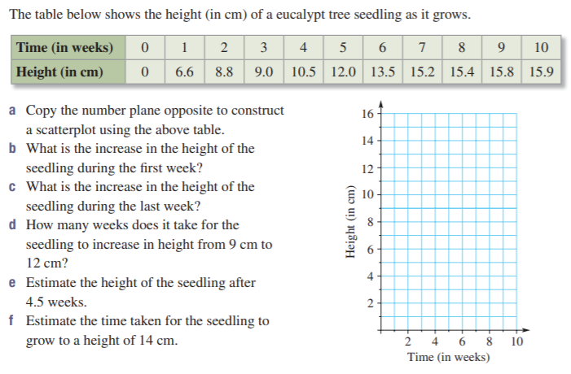
Delete this instruction and begin your answer here
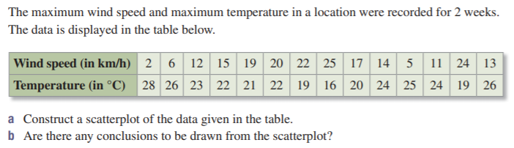
Delete this instruction and begin your answer here
4. | For those up for challenge!- see next page  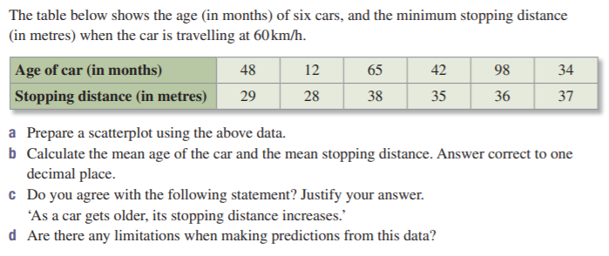  Delete this instruction and begin your answer here

